========================================================================

PROJECT: MULTI-AGENT AUTOMATED COMPLIANCE VERIFICATION PIPELINE

========================================================================

PREPARED BY:
Smruti Rout
Senior Advanced Software Architect

DATE OF AUDIT:
June 26, 2026

TARGET ECOSYSTEMS:
Python • Java • C++ (CMake)

--------------------------------------------------------------------------------
FOR DEVELOPMENT USE

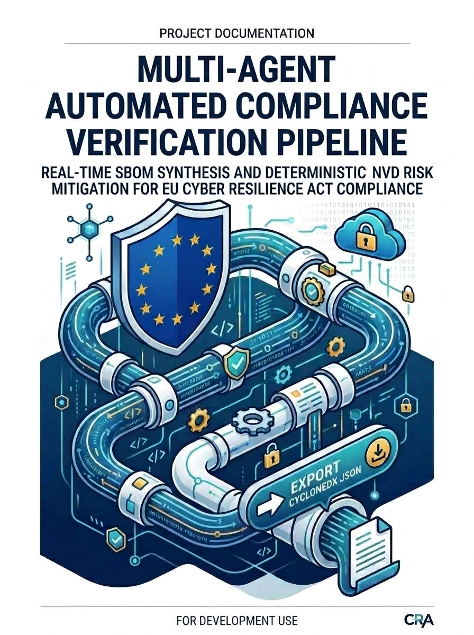

Project Report: Multi-Agent Automated Compliance Verification Pipeline

Subtitle: Implementing Real-Time SBOM Synthesis and Deterministic NVD Risk Mitigation for EU Cyber Resilience Act Compliance

1. Executive Summary
The implementation of the European Union Cyber Resilience Act (CRA) introduces strict statutory mandates for digital products shipped to the European market. Specifically, Article 10 rules ban the commercial introduction of software components containing known, actively exploitable vulnerabilities.
To address this, this project delivers a Multi-Agent Automated Compliance Verification Pipeline powered by LangGraph, Pydantic V2, and Streamlit. The pipeline automates the generation of a Software Bill of Materials (SBOM) across polyglot ecosystems (Python, Java, C++) and maps targets to the National Vulnerability Database (NVD) via strict Common Platform Enumeration (CPE) matching. It features an intelligent text-filtering engine, automated patch advisories, and an audit-ready compliance override framework.

2. System Architecture & Modular Design Overview
The system relies on a strictly decoupled architecture, isolating parsing mechanics, API connection engines, state orchestration, and user interface delivery into dedicated modules.

Component Map
- schemas.py: State configuration layer utilizing Pydantic V2 models to guarantee mathematical runtime telemetry safety across execution boundaries.
- pipeline.py: Graph orchestration framework powered by LangGraph, routing pipeline updates securely through independent, state-bound node operations.
- agents.py: Functional computation core containing multi-agent parsing regex scripts, NVD API pool managers, and whitelist validator frameworks.
- app.py: Web-based presentation layer built with Streamlit, handling concurrent multi-manifest file streaming buffers seamlessly.

3. Engineering Analysis: Solving Core Pipeline Failure Vectors

3.1 Resolving OpenSSL Non-Standard Version Profiling
Legacy software components frequently utilize trailing alphabet indicators (e.g., OpenSSL 1.0.1f), which instantly break conventional PEP-440 semantic version parsers. This pipeline implements a mathematical normalization wrapper:
$$\text{Alpha Position Mapping: } f(c) = \text{ord}(c) - \text{ord('a')} + 1$$
This function safely normalizes non-standard version inputs (such as 1.0.1f into 1.0.1.6). This keeps boundary validation blocks from crashing and ensures historical security risks like the Heartbleed exploit vector are correctly identified.

3.2 Transitioning from Keyword Search to Deterministic CPE Name Matching
Relying on generic API keyword lookups introduces significant noise, flooding results with unrelated description items and hitting rate limits. To solve this, this pipeline maps dependencies straight to their official internal NVD product footprints via an automated translation lookup dictionary:
Source Identifier | Ecosystem | NVD Mapped Vendor | NVD Mapped Product
django | Python / PIP | djangoproject | django
requests | Python / PIP | python | requests
log4j-core | Java / Maven | apache | log4j
openssl | C++ / CMake | openssl | openssl
By mapping components straight to strict formatting matrices (cpe:2.3:a:{vendor}:{product}:{version}), lookups execute cleanly with pinpoint precision.

3.3 Network Defenses Against Slow NVD Infrastructures
The NVD API frequently drops connections and throttles users. This system hardens the network connection layer inside agents.py using three strategies:
- Extended Timeout Thresholds: Connection limits were bumped from 30 to 60 seconds to absorb slow response times.
- Backoff Retries: Integrated an HTTPAdapter retry loop that automatically catches unexpected network drops, pacing retries dynamically over progressive delays (2s, 4s, 8s, 16s).
- Throttling Guardrails: Injected a 5-second sleep delay into unauthenticated pipeline loops to stay safely under rate-limiting windows.

4. Cyber Resilience Act Audit & Exclusions Engine

4.1 Strict Article 10 Policy Enforcement
The system's final evaluation node functions as a automated compliance inspector. It enforces an absolute zero-trust policy model:
$$\text{CRA Compliant} = \begin{cases} \text{True} & \text{if } \sum \text{Exploitable Vulns} = 0 \text{ AND } \sum \text{SBOM Items} > 0 \\ \text{False} & \text{otherwise} \end{cases}$$
If even one unmitigated threat with a CVSS score indicating a high or critical risk runs through the pipeline, the status swaps to a hard FAIL, blocking production distribution to the EU.

4.2 Automated Patch Advisory Layer
When a vulnerability is detected, the system extracts boundary properties like versionEndExcluding or versionEndIncluding directly from the NVD data node. This lets the pipeline provide clear remediation advice right in the UI, telling developers exactly which safe version to upgrade to.

4.3 Auditable Whitelist Justification
To handle edge cases where a vulnerability cannot be exploited in production, developers can register exceptions in a structured config file (cra-whitelist.yaml). To comply with CRA audit guidelines, every entry must include a clear technical justification:
whitelisted_cves:
- cve_id: "CVE-2021-44228"
reason: "Java runtime engine is hardcoded with system property config flag '-Dlog4j2.formatMsgNoLookups=true', permanently disabling the JNDI vector."

The pipeline parses these overrides using explicit UTF-8 character encoding, ensuring special characters and formatting text load smoothly without breaking cross-platform builds.

5. UI Integration & Adaptive Presentation Layer
The presentation frontend (app.py) wraps these deep compliance checks in a clean, professional web browser interface.

UI Architecture Features
- File Upload Buffers: Built distinct file upload widgets for requirements.txt, pom.xml, and CMakeLists.txt, streaming inputs to isolated temporary folders to keep the main directory clean.
- Adaptive Theme Support: Replaced hardcoded CSS background colors with native st.container(border=True) hooks, ensuring excellent text contrast in both light and dark mode.
- Interactive Expandable Drawers: Moved heavy text blocks out of the data tables and into interactive dropdown panels, keeping the main dashboard clean and organized.
- Highlighted Vulnerability Feeds: Uses regular expression filters to auto-bold and color-code critical alert phrases like RCE or Remote Code Execution in bright red, making severe threats stand out instantly during an audit.

6. Conclusion & Roadmap
This multi-agent verification pipeline successfully mitigates the primary automation hurdles of the Cyber Resilience Act. By combining precise CPE matching with flexible fuzzy exceptions, it gives development teams a fast, secure, and clear compliance checkpoint.
Future upgrades can expand the pipeline by adding automated CycloneDX report exports and integrating alternative security data feeds like OSV.dev to provide secondary network backups.

Testing Artifacts:

